Amino Acid Structures
The following amino acid structures are listed in alphabetical order. Ionizable groups are shown in their neutral form - this implies absolutely nothing about the predominant form at any particular pH.
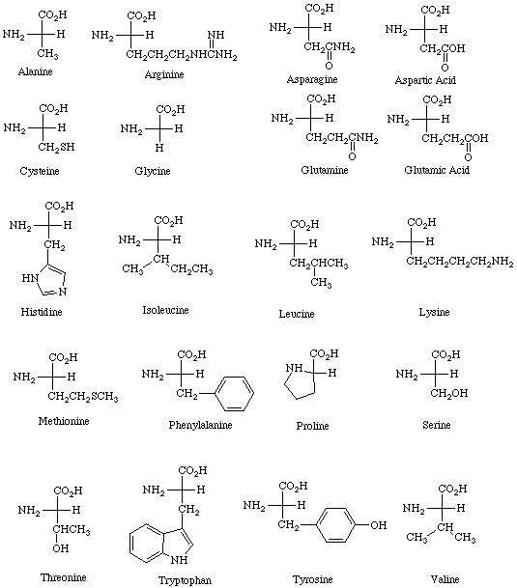

Amino Acid STRUCTURE (3D)

Physicological pH and Amino Acids: ZWITTERIONS
Amino Acid pK_{a} Values

Amino Acid | α-carboxylic acid  pK_{a} | α-amino  pKa=14-pK_{b} | Side chain | pI
Alanine | 2.35 | 9.87 |  | 6.00
Arginine | 2.01 | 9.04 | 12.48 | 10.76
Asparagine | 2.02 | 8.80 |  | 5.41
Aspartic Acid | 2.10 | 9.82 | 3.86 | 2.77
Cysteine | 2.05 | 10.25 | 8.00 | 5.07
Glutamic Acid | 2.10 | 9.47 | 4.07 | 3.22
Glutamine | 2.17 | 9.13 |  | 5.65
Glycine | 2.35 | 9.78 |  | 5.97
Histidine | 1.77 | 9.18 | 6.10 | 7.59
Isoleucine | 2.32 | 9.76 |  | 6.02
Leucine | 2.33 | 9.74 |  | 5.98
Lysine | 2.18 | 8.95 | 10.53 | 9.74
Methionine | 2.28 | 9.21 |  | 5.74
Phenylalanine | 2.58 | 9.24 |  | 5.48
Proline | 2.00 | 10.60 |  | 6.30
Serine | 2.21 | 9.15 |  | 5.68
Threonine | 2.09 | 9.10 |  | 5.60
Tryptophan | 2.38 | 9.39 |  | 5.89
Tyrosine | 2.20 | 9.11 | 10.07 | 5.66
Valine | 2.29 | 9.72 |  | 5.96
Last modified 2/4/97

Abby Parrill
Department of Chemistry
Michigan State University
These pages may be downloaded and linked from other pages freely for academic and educational purposes. Questions, problems, and errors should be sent toparrill@argus.cem.msu.edu.

